**Problem 1**

Content: 

Solution: Change line 29 to fgets(command, 16, stdin);

**Problem 2**

Content：



Solution: Change line 47 to: else if (command < 256)

processCommand(command);

**Problem 3**

Content：

Oh, what a hack…what a lovely hack!



Solution: Change line 24 to printf(“%s”, input);

**Problem 4**

Content：



Solution: First tell if public.txt is a link. Only execute when public.txt is not a link. The program should be as follows:

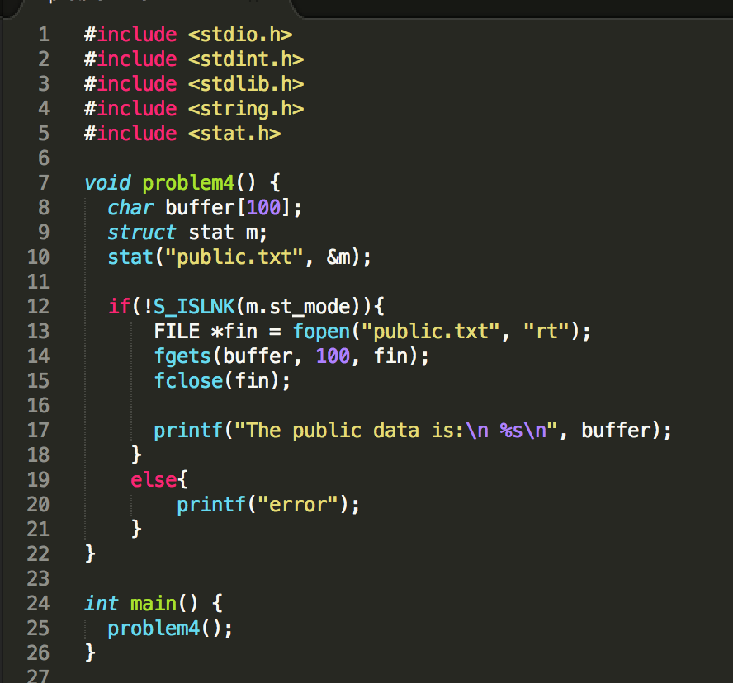

**Problem 5**

Content:

Solution: Change line 28 to printf(“%s”, user->username);